**LAB TASK # 04**

**MOHAMMAD BASIL ALI KHAN**

**20K-0477**

**Task#01:**

* **Main Menu**

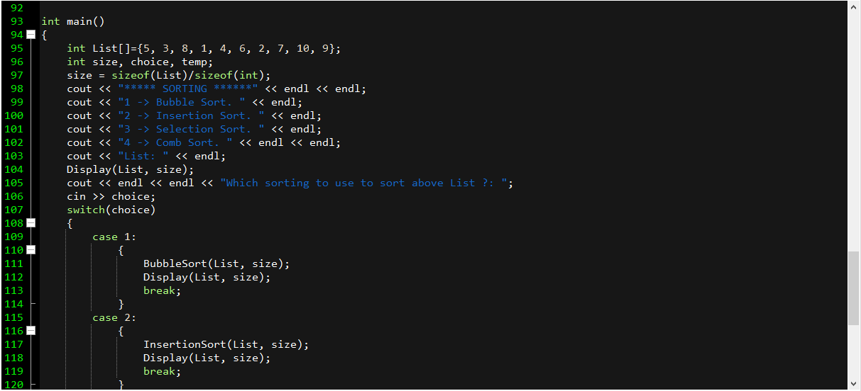

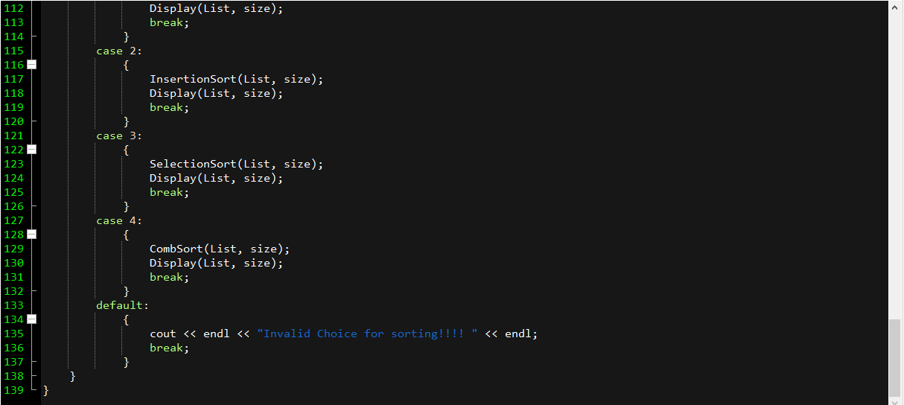

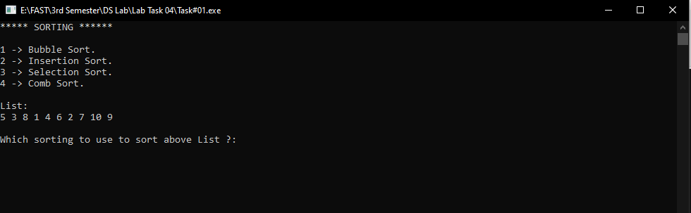

* **Bubble Sort**

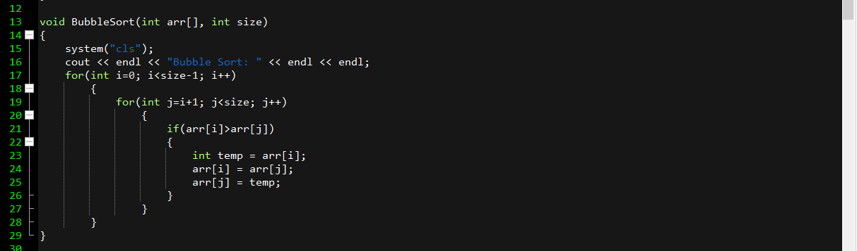

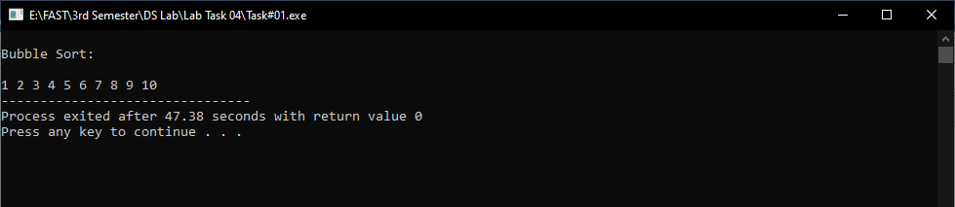

* **Insertion Sort**

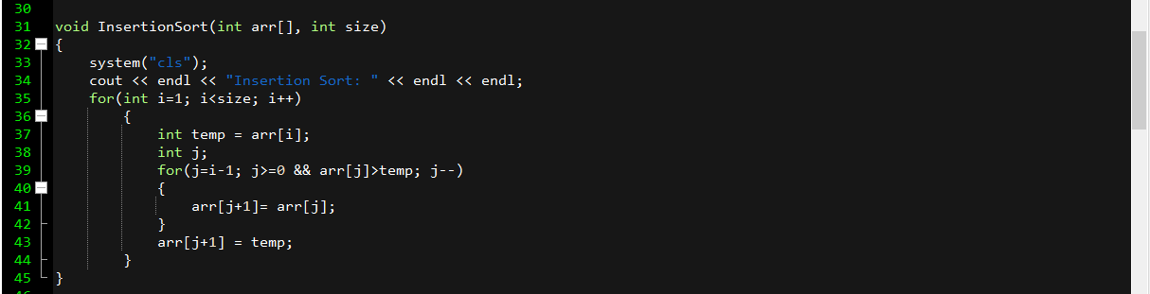

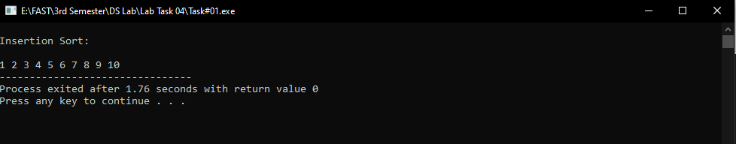

* **Selection Sort**

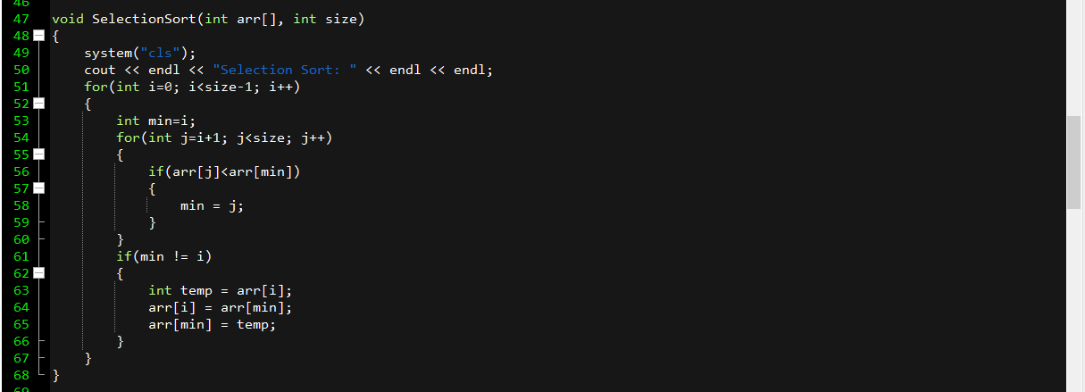

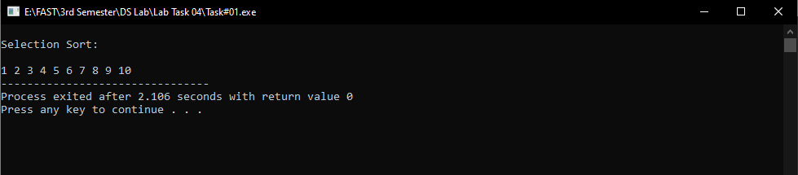

* **Comb Sort**

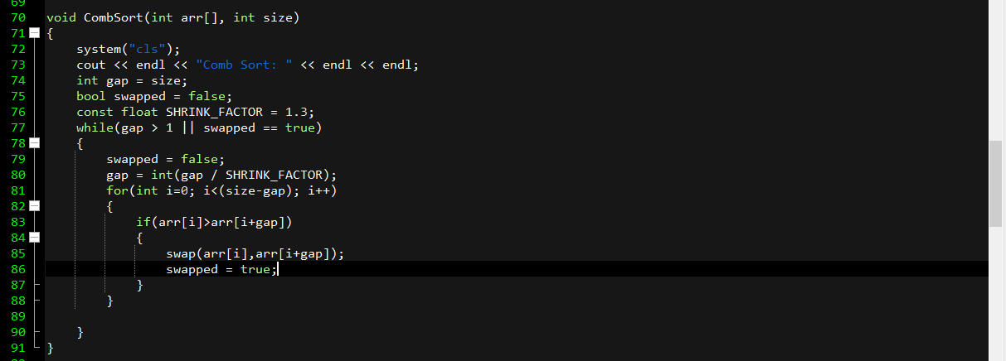

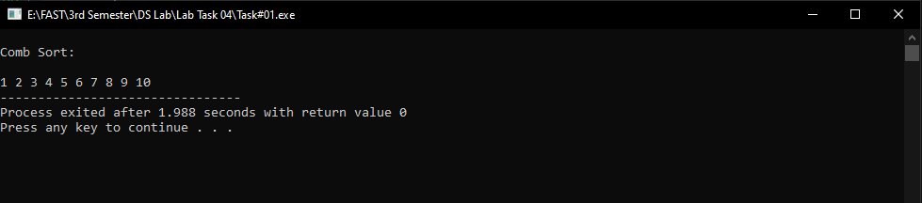

**Task#02:**

* **Code**

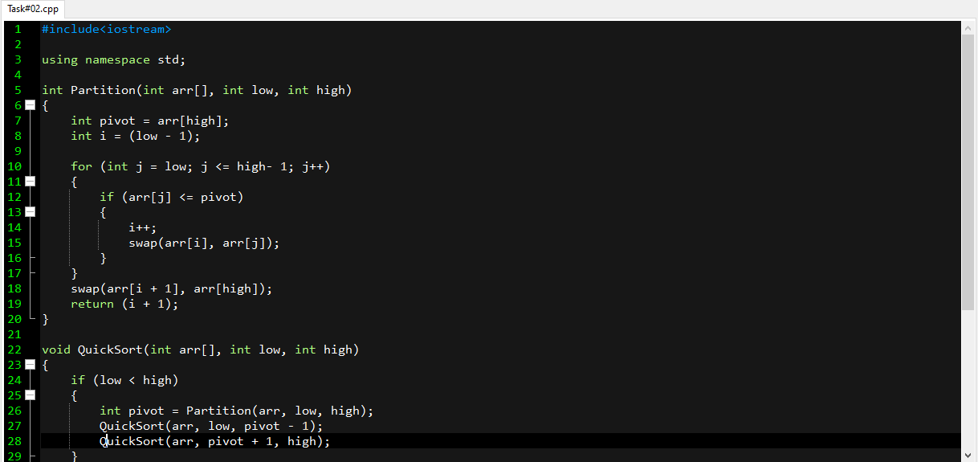

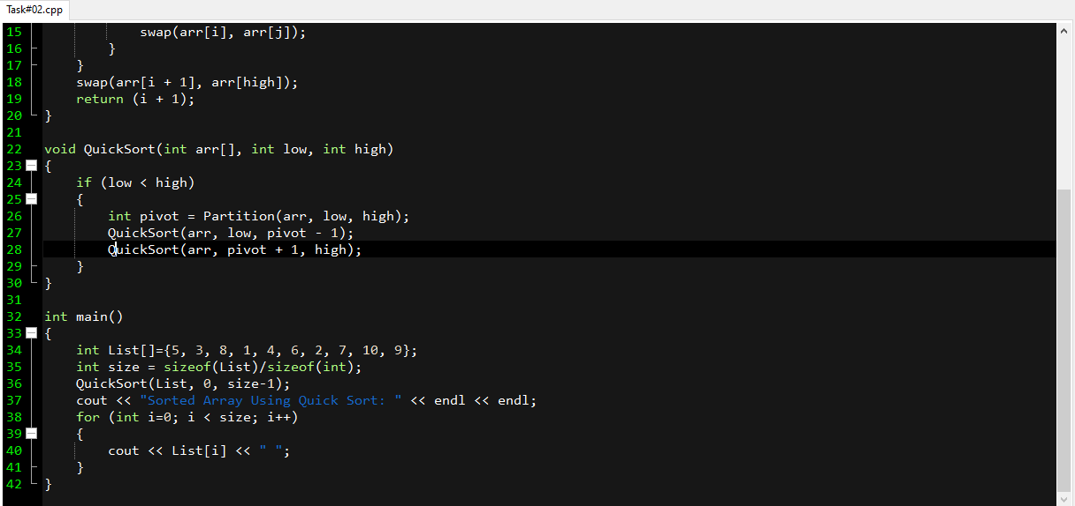

* **Output**

